Front Cover

Adarsh Chakka

WHSG

Candidate number: 7071

Centre number 16337

Contents:

Analysis: 2

Implementation 9

Testing 9

Evaluation 10

Bibliography and sources 11

Appendices 12

# Analysis:

Your project name: ATC Simulation – London Heathrow Airport.



Initial brainstorm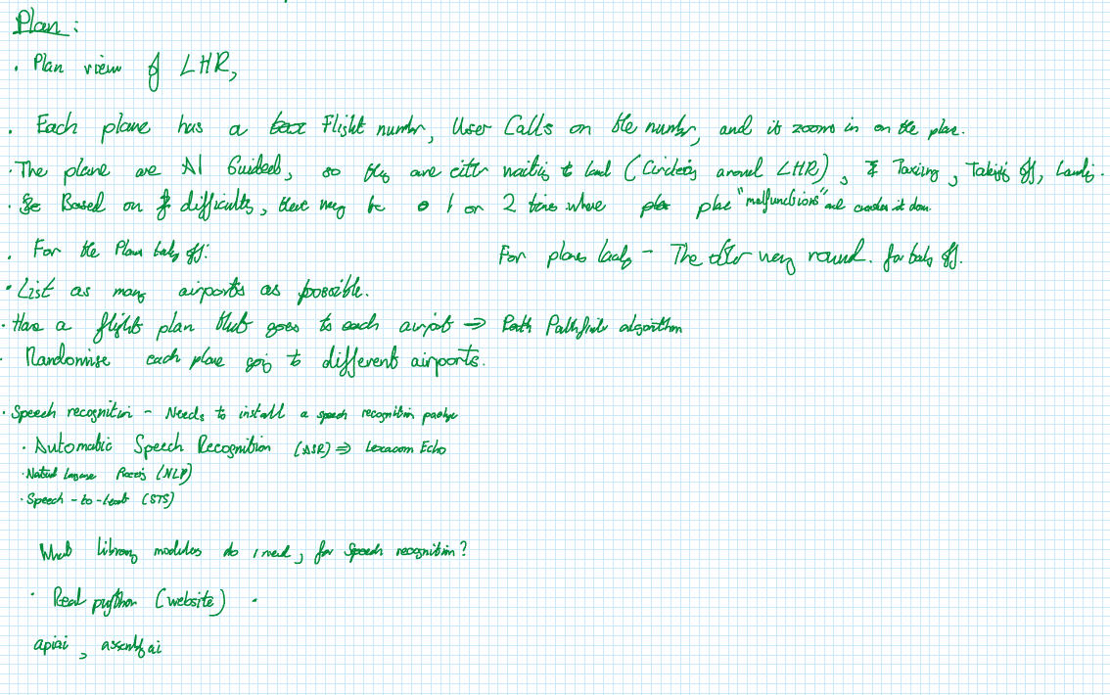

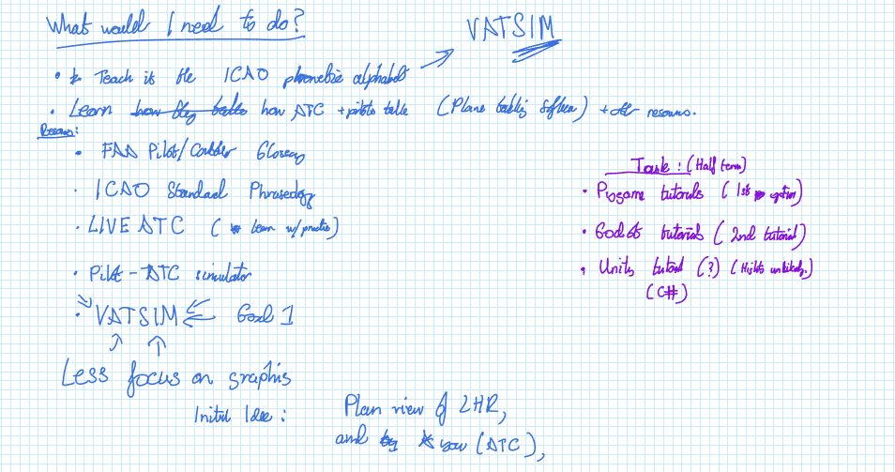

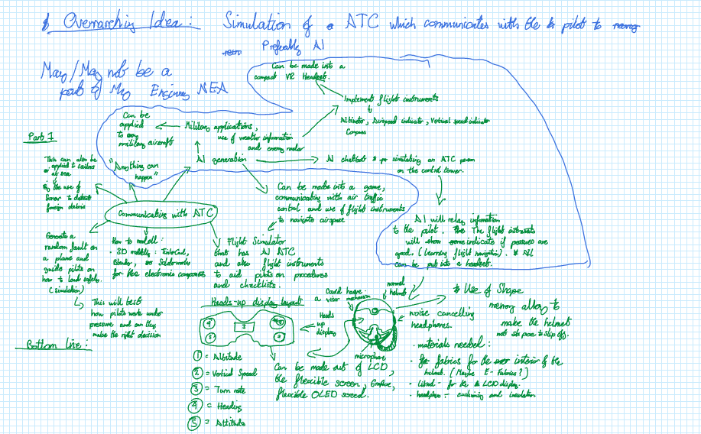

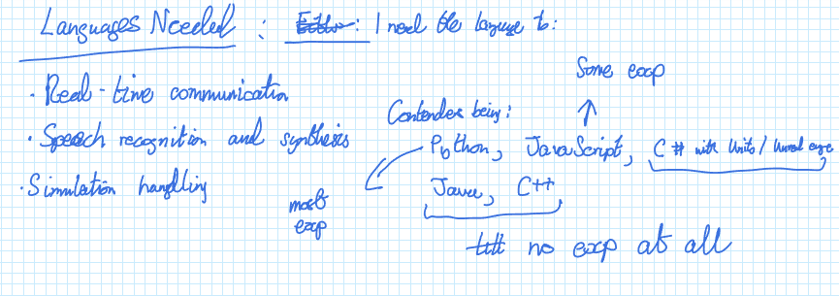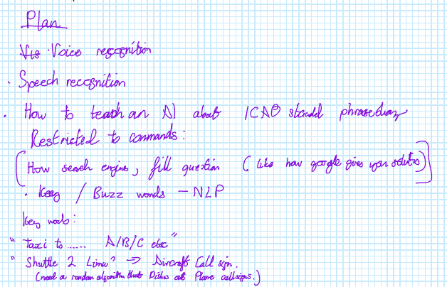

Computing Problem:

Due to the Global Pandemic, a multitude of people in the aviation industry including Pilots, Engineers, Maintenance staff, Landside and airside staff and Air traffic controllers have been limited or made redundant. As these restrictions eased, current and/or novice Air Traffic controllers will find it imperative to remember how to communicate with the pilots using the ICAO standard terminology, study weather patterns, to forecast weather patterns, post-Covid. Simultaneously, new and upcoming ATCOs (Air Traffic Control Officers) need to understand the terminology necessary to avoid any problems on Airside. Your task is to design, implement and test a solution to this problem.

Computational Approach:

My project is well suited for a computational approach because the problem I am solving for, has many factors. While ATCO’s (Air Traffic Control Officers) are training, they are tested on the following:

* Using the ICAO Standard Phraseology when communicating with pilots, ground staff and airport staff
* Predicting weather and analysing weather patterns that influence the aircrafts ascent/descent
* Handling multiple planes simultaneously which requires troubleshooting, decision-making, coordination and complex problem-solving skills
* How they react under pressured environments and having a role to play in the safety of 100+ souls onboard

These criteria for ATCOs can be simulated by:

* Creating a language model and teach a subsection of the ICAO standard terminology to it
* Utilise speech recognition libraries for the language models to pick out the keywords when the user speaks into it
* A plan view of London Heathrow and having planes during taxiing, departure and landings
* Implementing weather systems that affect the rate of descent of the plane – which can lead to situational awareness for the ATCO which extends onto a different aspect of training. This can also lead to priority landings. (optional)

Another reason why a computational approach is more viable is because training to become an ATCO when you are starting out can be daunting at first – it goes for many jobs however there is the added risk of lives onboard if instructions are mishandled. As a result, a far more convenient space to train would be the virtual world – even though trainee officers make mistakes, there are more minimal consequences – allowing for learning opportunities.

**How the problem can be solved by computational methods:**

My problem can be broken down into sub functions that can be tested individually and can be brought together to make the final product. As my project will have speech recognition, path finding algorithms and Natural language processing, it will be easier to code for each of these functions separately before concatenating them into a computing prototype.

**Thinking Abstractly:**

My simulation will be abstracted because it focuses on the voice recognition capabilities therefore it does not need as much graphics involved. This will include:

* Background will stay the same, as the airport is stationary. For the weather component, mimicking reality will heavily rely on graphics, as this is a simulator focusing on instructions, I would emphasise the weather using minimal graphics, however when it comes to visibility levels, I would need to dim the airport down to simulate fog/ cloudy weather.
* The flight paths of these planes will also need to be abstracted, making the plane act as objects to either depart or land from the airport. As my project revolves around London Heathrow Airport, the action of the planes landing at the receiving airport can be considered negligible, therefore once the plane has taken off/landed, the plane's flight paths can be halted, must go to the general area of the receiving airport.
* Banner for when the plane takes a wrong route – if the plane (object) is given an incorrect runway, taxi route, or has crash collided with another plane, the banner should be a simple Retry/ Exit. There could also be a voice function to exit the simulator.

**Stakeholder considerations:**

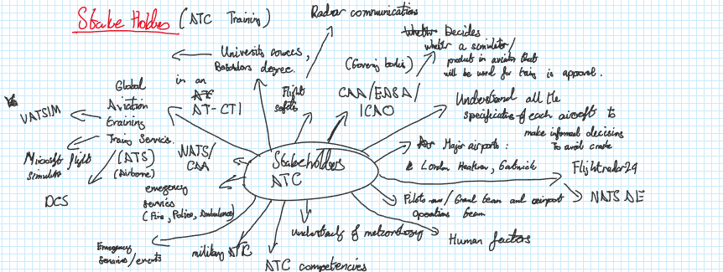

My stakeholders can be categorised into 3 categories:

**Training and Education / Airports and Airfields / Governing bodies:**

**Training and Education** – encompasses stakeholders that teach, train and approve junior ATCOs as they embark on their ATC career. To be an ATCO, the minimum requirements are GCSES and/or A levels, however alongside their academic requirements, they must also undergo specialist training allowing them to attain ATCO licences. They must attain a Class 3 medical licence by a CAA approved medical centre. For alternate graduate schemes such as degree apprenticeships, NATS holds a 4-year graduate scheme with a year placement at NATS to be an ATCO. Furthermore, the training instruments that are currently being used must be CAA compliant as a licence is having the right to authorise take-offs, landings, and overall flight path guidance for all planes flying in the sky. Although there are 2 popular training sites for ATCOs such as Global Aviation training services and NATS, they provide initial Training for 3 types of ATC that people can station for: ADI (Aerodrome Control Instrument), APP (Approach control Office), APS (Approach control surveillance) ratings that are mandatory to obtain an ATCO licence. Therefore, my product should be able to give an insight into Air traffic control to either obtain “Controller” experiences on a virtual platform. Software platforms such as VATSIM, Microsoft flight simulator, and other 3rd party flight simulator platforms that have an ATC component. Flightradar24 and NATS AE are GPS-based, plane tracking software for users or anybody having a passion for the aviation industry. As my project revolves around communicating with ATC, it serves as a solid foundation on how I can develop multiple ideas. My solution will be useful to train junior ATCOs building up their competencies, allowing them to delegate different planes to different runways or to decide priority landings.

**Airports and Airfields** – Encompasses stakeholders that are airports in operation 24/7. These include popular airports such as LHR, LGW, MAN that are always in constant operation. This doesn't exclude other airbases such as Duxford, Cambridge, and Oxford airport. They also require ATCOs present whether assisting with flight training for pilots or clearing the runway for an emergency landing. As not only ATCOs are being trained, ground team, airport operation teams, pilots, and even aircraft engineers are also being trained at similar times and will need access to an airbase/airport required to fulfil their training. There are 3 types of operators that an ATCO can take: Aerodrome (Control tower), Area and Approach Controllers. All of which are needed to have a comprehensive understanding of meteorology, chart reading, to forecast weather patterns to either direct planes to land or advise against strong winds. My solution will help ATCOs getting accustomed to their surroundings, whether in a control tower or controlling over an FIR, relying on instrument rating and human factors. By including weather induced surroundings to my solution, would best achieve similarity to what ATCs must direct daily.

**Governing bodies** – These are international organisations that provide pilot, aircraft engineers, ATC and airside staff, their licences to fly, direct, manufacture and control planes to their destination. Organisations such as the Civil aviation Authority, National Air tracking services, International Civil Aviation organisation all serve the purpose of flight safety. These organisations are also looking into new and sustainable technologies such as hydrogen fuel cells, the use of AI in terms of training and integrating quantum computing into aviation systems to log weather patterns, or confidential data to compress data, allowing for more storage. They also play a huge factor when it comes to medical requirements, for control officers, they must obtain a Class 3 medical licence by the CAA. In a real-time setting, if training COs makes a misjudgement via a communication error, it could result in drastic consequences, putting the passengers, cabin crew, pilots and maybe even ground staff (if in proximity) in danger. Making a virtual world more suitable for practice. My solution can help by acting as an exam component that training COs must take to get their licences then to be stationed either in an airfield, or at an airport. Testing the way that they handle normal landings but also have a difficulty component when a flight has a supposed fault which requires a priority landing or otherwise communicated to by pilots. This can assess how well they react to stress signals and boost their overall thinking skills and competencies.

Design

Analysis: 2

Implementation 4

Testing 5

Evaluation 6

Bibliography and sources 7

Appendices 8

# Implementation

# Testing

# Evaluation

# Bibliography and sources

# Appendices